**Assignment -1**

**Code:**

<!doctype html>

<html lang="en">

<head>

<!-- Required meta tags -->

<meta charset="utf-8">

<meta name="viewport" content="width=device-width, initial-scale=1, shrink-to-fit=no">

<!-- Bootstrap CSS -->

<link rel="stylesheet" href="https://cdn.jsdelivr.net/npm/bootstrap@4.1.3/dist/css/bootstrap.min.css" integrity="sha384-MCw98/SFnGE8fJT3GXwEOngsV7Zt27NXFoaoApmYm81iuXoPkFOJwJ8ERdknLPMO" crossorigin="anonymous">

<title>Hello, world!</title>

</head>

<body>

<form style="margin:42px 357px;" class="rounded border border-primary d-flex flex-column justify-content-center align-items-center">

<h1 class="mt-3 text-center">Registration Form</h1>

<div class="form-group w-75 mt-5">

<label for="exampleFormControlInput1">Name</label>

<input type="Name" class="w-100 form-control" id="exampleFormControlInput1" placeholder="Name">

</div>

<div class="form-group w-75 mt-5">

<label for="exampleFormControlInput1">Email address</label>

<input type="email" class="w-100 form-control" id="exampleFormControlInput1" placeholder="name@123.com">

</div>

<div class="form-group w-75">

<label for="exampleFormControlInput1">Phone Number</label>

<input type="number" class="w-100 form-control" id="exampleFormControlInput1" placeholder="e.g 8097791270">

</div>

<div>

<button type="button" style="width: 136px;height: 45px;" class="my-5 mx-5 btn btn-dark">Submit</button>

<button type="button" style="width: 136px;height: 45px;" class="my-5 mx-5 btn btn-dark">Cancel</button>

</div>

</form>

<!-- Optional JavaScript -->

<!-- jQuery first, then Popper.js, then Bootstrap JS -->

<script src="https://code.jquery.com/jquery-3.3.1.slim.min.js" integrity="sha384-q8i/X+965DzO0rT7abK41JStQIAqVgRVzpbzo5smXKp4YfRvH+8abtTE1Pi6jizo" crossorigin="anonymous"></script>

<script src="https://cdn.jsdelivr.net/npm/popper.js@1.14.3/dist/umd/popper.min.js" integrity="sha384-ZMP7rVo3mIykV+2+9J3UJ46jBk0WLaUAdn689aCwoqbBJiSnjAK/l8WvCWPIPm49" crossorigin="anonymous"></script>

<script src="https://cdn.jsdelivr.net/npm/bootstrap@4.1.3/dist/js/bootstrap.min.js" integrity="sha384-ChfqqxuZUCnJSK3+MXmPNIyE6ZbWh2IMqE241rYiqJxyMiZ6OW/JmZQ5stwEULTy" crossorigin="anonymous"></script>

</body>

</html>

**Output:**

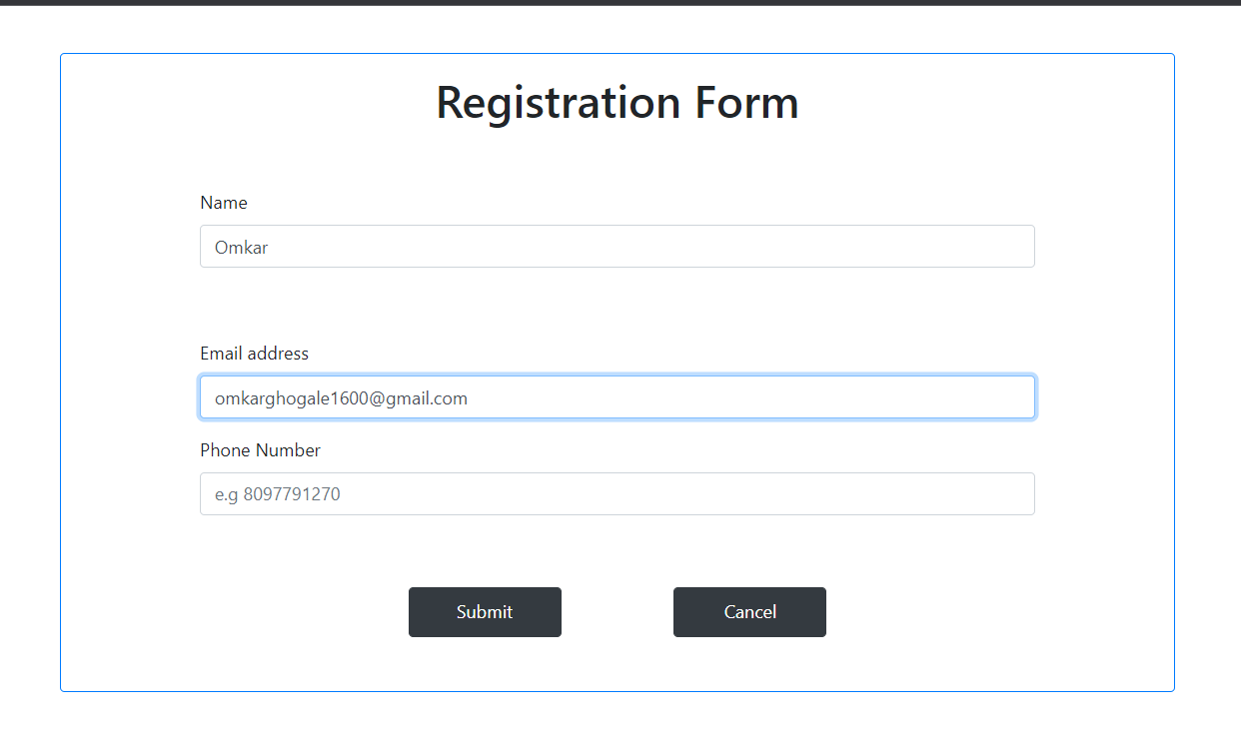

**Code:**

<!doctype html>

<html lang="en">

<head>

<!-- Required meta tags -->

<meta charset="utf-8">

<meta name="viewport" content="width=device-width, initial-scale=1, shrink-to-fit=no">

<!-- Bootstrap CSS -->

<link rel="stylesheet" href="https://cdn.jsdelivr.net/npm/bootstrap@4.1.3/dist/css/bootstrap.min.css" integrity="sha384-MCw98/SFnGE8fJT3GXwEOngsV7Zt27NXFoaoApmYm81iuXoPkFOJwJ8ERdknLPMO" crossorigin="anonymous">

<title>Media-Obects</title>

<style>

.logo{

align-content: center;

left: 407px;

margin: 0 43%;

width: 13%;

margin-top: 1%;

}

</style>

</head>

<body>

<img src="th-916627854.jpg" class="logo" alt="">

<div class="media mt-5 mx-5">

<div class="media-body">

<h5 class="mt-0">Devops</h5>

By definition, DevOps outlines a software development process and an organizational culture shift that speeds the delivery of higher quality software by automating and integrating the efforts of development and IT operations teams – two groups that traditionally practiced separately from each other, or in silos.

In practice, the best DevOps processes and cultures extend beyond development and operations to incorporate inputs from all application stakeholders - including platform and infrastructure engineering, security, compliance, governance, risk management, line-of-business, end-users and customers - into the software development lifecycle.

<div style="background-color:#d1e7ff ;" class="media my-4 mt-5 rounded p-4">

<img style="height: 55px;" class="align-self-center mr-3" src="Docker_logo_011.png" alt="Generic placeholder image">

<div class="media-body">

<h5 class="mt-0">Docker</h5>

<p>Docker is an open source platform that enables developers to build, deploy, run, update and manage containers—standardized, executable components that combine application source code with the operating system (OS) libraries and dependencies required to run that code in any environment.

Containers simplify development and delivery of distributed applications. They have become increasingly popular as organizations shift to cloud-native development and hybrid multicloud environments. It’s possible for developers to create containers without Docker, by working directly with capabilities built into Linux and other operating systems.

</p>

</div>

</div>

<div style="background-color:#d1e7ff ;" class="media my-4 rounded p-4">

<div class="media-body">

<h5 class="mt-0">Kubernetes</h5>

<p>Kubernetes was first developed by engineers at Google before being open sourced in 2014. It is a descendant of Borg, a container orchestration platform used internally at Google. Kubernetes is Greek for helmsman or pilot, hence the helm in the Kubernetes logo (link resides outside IBM).

Today, Kubernetes and the broader container ecosystem are maturing into a general-purpose computing platform and ecosystem that rivals — if not surpasses — virtual machines (VMs) as the basic building blocks of modern cloud infrastructure and applications. This ecosystem enables organizations to deliver a high-productivity Platform-as-a-Service (PaaS) that addresses multiple infrastructure-related and operations-related tasks and issues surrounding cloud-native development so that development teams can focus solely on coding and innovation.</p>

</div>

<img style="height: 65px;" class="align-self-center mr-3" src="th-1136044728.jpg" alt="Generic placeholder image">

</div>

</div>

</div>

<!-- Optional JavaScript -->

<!-- jQuery first, then Popper.js, then Bootstrap JS -->

<script src="https://code.jquery.com/jquery-3.3.1.slim.min.js" integrity="sha384-q8i/X+965DzO0rT7abK41JStQIAqVgRVzpbzo5smXKp4YfRvH+8abtTE1Pi6jizo" crossorigin="anonymous"></script>

<script src="https://cdn.jsdelivr.net/npm/popper.js@1.14.3/dist/umd/popper.min.js" integrity="sha384-ZMP7rVo3mIykV+2+9J3UJ46jBk0WLaUAdn689aCwoqbBJiSnjAK/l8WvCWPIPm49" crossorigin="anonymous"></script>

<script src="https://cdn.jsdelivr.net/npm/bootstrap@4.1.3/dist/js/bootstrap.min.js" integrity="sha384-ChfqqxuZUCnJSK3+MXmPNIyE6ZbWh2IMqE241rYiqJxyMiZ6OW/JmZQ5stwEULTy" crossorigin="anonymous"></script>

</body>

</html>

**Output:**

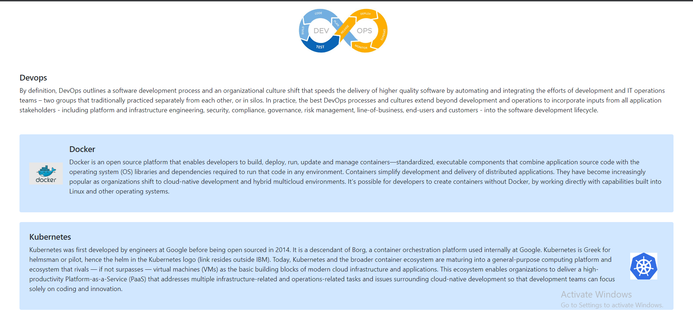

**Code:**

<!doctype html>

<html lang="en">

<head>

<meta charset="utf-8">

<meta name="viewport" content="width=device-width, initial-scale=1, shrink-to-fit=no">

<link rel="stylesheet" href="https://cdn.jsdelivr.net/npm/bootstrap@4.1.3/dist/css/bootstrap.min.css" integrity="sha384-MCw98/SFnGE8fJT3GXwEOngsV7Zt27NXFoaoApmYm81iuXoPkFOJwJ8ERdknLPMO" crossorigin="anonymous">

<title>Resume using bootstrap</title>

<style>

.main{margin: 0 173px;}

.width{width: 29%;}

.svg{

width: 15px;

margin-right: 15px;

margin-top: 1px;

}

</style>

</head>

<body>

<div class="main row">

<div class="col-md-4 p-4 w-100">

<div><img class="width mb-3 ml-5 rounded-circle" src="img/man.jpg" alt=""></div>

<div class="per-info d-flex flex-column">

<div class="my-1">

<span>9082375884</span>

</div>

<div class="my-1">

<span>Omkar@gmail.com</span>

</div>

<div>

<span>Mumabai, Maharastra</span>

</div>

</div><hr>

</div>

<div class="col-md-8">

<div class="name"><h1>Omkar Ghogale</h1></div>

<hr>

<div class="imf">

<p class="mt-5"> Lorem ipsum dolor sit amet consectetur, adipisicing elit. Provident corporis vero porro enim, repellat officiis aperiam aliquam pariatur, dolorem, eos distinctio eveniet sapiente est minima ut! Velit, repudiandae laudantium. Odit.</p>

</div><hr>

</div>

<div class="col-md-4">

<h5><b>SKILLS</b></h5>

<div class="mt-4 d-flex">

<span class="mr-3 font-weight-normal">Python</span>

<div class="stars d-flex align-items-center">

</div>

</div>

<div class="mt-3 d-flex">

<span class="mr-3 font-weight-normal">ML,AI,Deep Learning</span>

<div class="stars d-flex align-items-center">

</div>

</div>

<div class="mt-3 d-flex">

<span class="mr-3 font-weight-normal">Mysql</span>

<div class="stars d-flex align-items-center">

</div>

</div>

<div class="mt-3 d-flex mb-4">

</div><hr>

</div>

<div class="col-md-8">

<div class="projects">

<h5 class="mb-3"><b>PROJECTS</b></h5>

<div class="1 my-2">

<span><b>ML Algorithm Comparaarer</b></span><br>

<div class="">- Lorem ipsum dolor sit, amet consectetur adipisicing elit. Nobis nisi laborum repellat adipisci! Aspernatur, iste nisi! Fugit sit pariatur veritatis voluptatem aut, delectus amet corporis sapiente maiores nesciunt blanditiis in.</div>

</div>

<div class="2 my-2">

<span><b>Malaria Detection Using CNN</b></span><br>

<div class="px-3">- Lorem ipsum dolor sit amet consectetur adipisicing elit. Quasi ducimus officia rem consequuntur, ipsum amet similique? Labore alias voluptate consectetur, ipsam voluptas enim officiis, explicabo est corporis eligendi nihil impedit.</div>

</div>

</div>

</div>

<div class="col-4">

<div class="mb-3">

<h5><b>EDUCATION</b></h5>

<span><b>Bachelor of Engineering</b></span><br>

<span>Mumbai University</span><br>

<span class="font-weight-light">current</span><br>

<span class="font-weight-light">courses</span><br>

<span>- Information Technology</span>

</div>

</div>

<div class="col-8">

<div class="1 my-2">

<span><b>ESHOP Website</b></span><br>

<div class="px-3">- Lorem ipsum dolor sit amet, consectetur adipisicing elit. Saepe nobis aliquam incidunt laudantium quisquam, neque dignissimos sapiente impedit esse molestias? Tempore repellat voluptatibus quo sunt, ad ipsa eos! Aliquam, dolores.</div>

</div>

</div>

</div>

<script src="https://code.jquery.com/jquery-3.3.1.slim.min.js" integrity="sha384-q8i/X+965DzO0rT7abK41JStQIAqVgRVzpbzo5smXKp4YfRvH+8abtTE1Pi6jizo" crossorigin="anonymous"></script>

<script src="https://cdn.jsdelivr.net/npm/popper.js@1.14.3/dist/umd/popper.min.js" integrity="sha384-ZMP7rVo3mIykV+2+9J3UJ46jBk0WLaUAdn689aCwoqbBJiSnjAK/l8WvCWPIPm49" crossorigin="anonymous"></script>

<script src="https://cdn.jsdelivr.net/npm/bootstrap@4.1.3/dist/js/bootstrap.min.js" integrity="sha384-ChfqqxuZUCnJSK3+MXmPNIyE6ZbWh2IMqE241rYiqJxyMiZ6OW/JmZQ5stwEULTy" crossorigin="anonymous"></script>

</body>

</html>

**Output:**

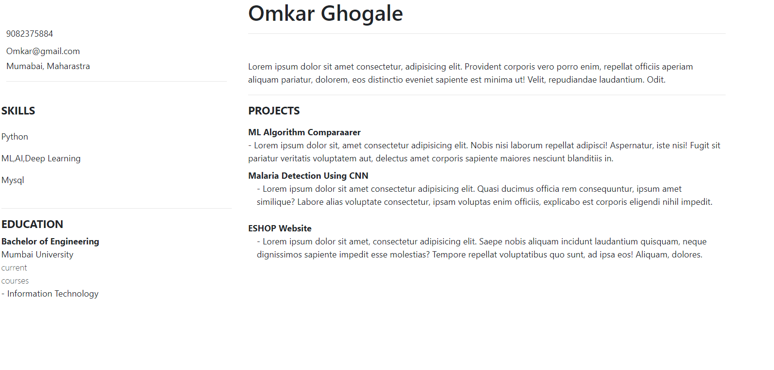

**Code:**

<html>

<body>

<table border=1 cellspacing="0"><tr>

<th colspan="6"> Time Table </th>

</tr><tr>

<td rowspan="6"> Hours </td>

<th> mon </th>

<th> tues </th>

<th> Wed </th>

<th> Thrus</th>

<th> Fri </th>

</tr><tr>

<td> ADSA </td>

<td> Maths</td>

<td> IP</td>

<td> EEB </td>

<td> CNS</td>

</tr><tr>

<td> ADSA </td>

<td> Maths</td>

<td> ADSA</td>

<td> Maths </td>

<td> EEB</td>

</tr><tr>

<th colspan="5"> Lunch </th>

</tr><tr>

<td> EEB </td>

<td> Maths</td>

<td> CNS</td>

<td> Maths </td>

<td rowspan="2"> Project </td>

</tr><tr>

<td> IP </td>

<td> Maths</td>

<td> IP</td>

<td> Maths </td>

</tr>

</table>

</body></html>

**Output:**

